All code available at:

<https://github.com/RebelShadow/Capata-Andrei-Bogdan_30332_II>

LAB1

1. 2.

3. 4.

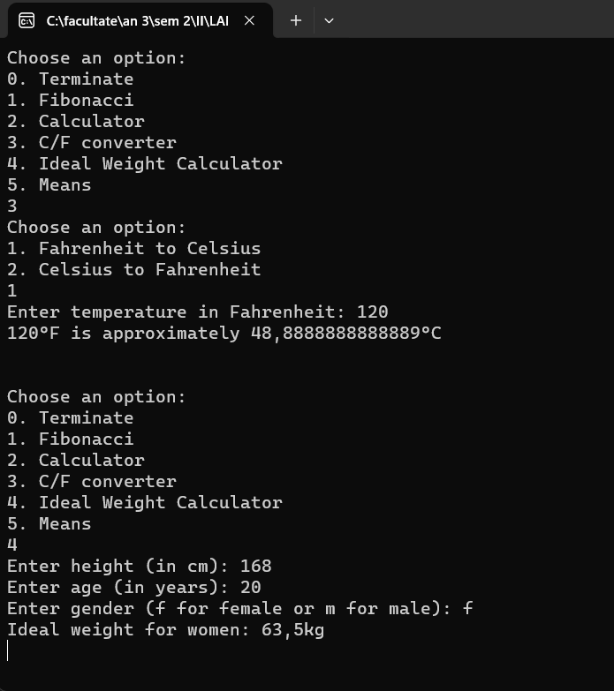

5.

LAB2

1.

2.

3.

4.

